***1. Executive Summary***

* 1. ***Purpose***

This document is meant for online shopping cloth web application is to intend to provide complete solutions of vendors as well as customers through single get way using internet. It will enable vendors to step up online shops, to browse through the shop and purchase online without visiting the shop physically.

* 1. ***Purpose and Scope of this Specification***

This system allows the customer to maintain their cart for add or cancel the product trough internet.

***2. Product/Service Description***

***2.1 Product context***

Show the product context of Sales and marketing and how does it interface with the other system. If customer want to buy some clothes via online she/he needs to register to the online shop which scope of sales and marketing before customer get the product she/he must need to filled and do the create account, manage account, place order, add to cart and cancel if the user change his/her mind while ordering. But before that happen sales and marketing has interface to the other system such: Human resource to get the employees hiring and support, ware house to order and ship the product and last is Accounting and Finance to collect the money from the customer.

Diagram 2.1

(Sales & Marketing)

* Create Account
* Manage Account
* Place order
* Cancel order



**Customer Payment**

**Register**

**Customer**

**Accounting**

**Employee**

**Product**



**Human Resource**

**Ware House**

***2.2 User Characteristic***

**Student** every student represent as a user that takes the test of clothes online shop that we may consider as improvement in sales and marketing interface.

**Staff** to had a rapidly sales a staff must have a clear communication skill to customer and in system interface

**Server** is the system that accepts multiple connections from customer and the serves that result.

**Admin** has the authority to grant/delete register members as well as view profile.

**Customer** register members can access all the functionalities provide on website and had their own pofile.

***2.3 Assumptions***

* User has an active internet connection or has access to one to view the website.
* The user have at least basic knowledge of computer
* The users know the English language, as user interface uses.

***2.4 Constraints***

The system should build using a web page development tool like HTML, XAMPP

The information of all the users must be stored in a database that is accessible by the administrator.

The user can access system from any computer that has internet connection.

***2.5 Dependencies***

The system depends in the following:

* It does depend in Supply Chain Management, any of the purchase product of sales and marketing has order from the stock of SCM. If SCM process occurs some failure the Sales and marketing might have a problem about the product too.
* Sales and Marketing system depend in accounting system, the data of the product that enter from Sales was direct to Accounting system.
* It depend in Human Resource system in assigning employee and also at the Employees hiring that scope of Sales and marketing and its direct from human resource system.

**3. Requirements**

***3.1 Functional Requirements***

When using a system the first interface that might see are the system home page that includes Home, Product, Apply Job, About Us, Feedback, Sign up and the Login navigation bar.

3.1.1 When clicking the Home it will view the:

* Feature Products, pucrases some of the trends product and customer can choose order from it. And will click the
* Add to cart button if customer had already done in shopping.
* Shopping cart will appear from the top right side of the system and it will view the customer order and its specs. Correspond in
  + Clear cart, all of the order should clear and it back from the home.
  + Check out total it’s either continue shopping or pay on store
* Continue shopping button will help the customer to add the product that they want to add to their cart.
* Pay on store it has four (4) parts that must need to fill up include the Account, Personal Data, Payment, Confirm
* The Account form required customer Full name, Email and Postal Code then click the account button then the next things will show up its
* Personal data includes Address, country, City and phone number after filling up then click the personal data at the lower part of the system.
* Payment includes how much is the appropriate shipping fee of customers order is has auto generate in the system and also has a Delivery address and Total amount of the product that customers order.
* Confirm the last process for pay on store the customer should click the “proceed” button if she/he are surely want to order the product.

3.1.2 About Us, are viewing the vision of the system and does the customer contact us in case of error.

3.1.3 Apply Job

For the person who want to apply job should fill up the form that includes Employee ID, Full Name, position, Salary then lick the submit button and it will direct from the Human Resource system.

3.1.4 Feedback, need a requirements such a customer ID, Name, Email, Mobile Number and has a form for customers for any suggestion, recommendation “feedback” about the services. The click the submit button.

3.1.5 Sign up customer must need to create an account to easy access when in delivery process. Customer need to fill up the form that includes Registration ID, Full name, Contact Number, Email, Address, Username and Password the click the sign up button, after clicking the button the Log in will pop up.

3.1.6 Log in, the user name and password that customer fill from sign up will be the username and password that is uses in log in form. Customer must log in a valid username and password. then click the Log in button.

**3.1.7 Registration**

If the customer are new and don’t have any account in shop she/he must be register to shop if not the user can’t go to the shopping cart.

**3.1.3 Add to Cart**

When customers done to shopping cart she/he can add to the cart and place the order.

**3.1.4 Change to Cart**

If the customers change his/her mind then it can cancel the order of the product from shopping cart

**3.1.5 Logout**

After ordering product the customer must logout his/her account from website.

***3.2 User Interface Requirements***

The various interface of the product could be:

1. Login Page
2. Registration Form
3. Information about the product (Price, Brand, Quantity, Size, Color)
4. If the user clicks the button add to cart then another screen of shopping cart should be open.

Home Page

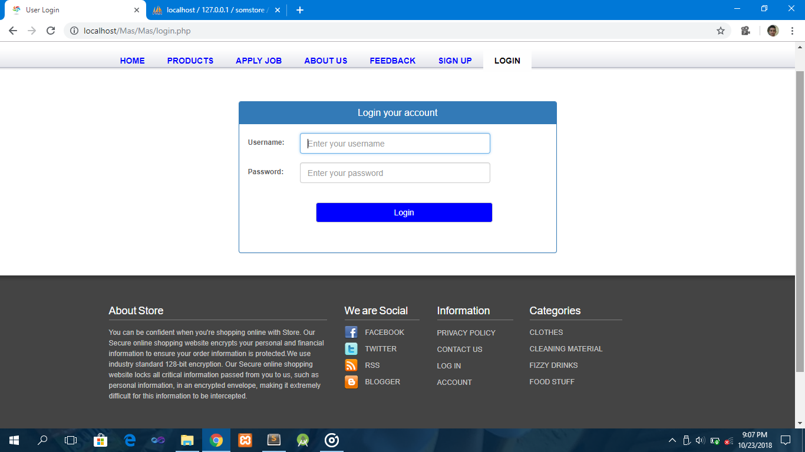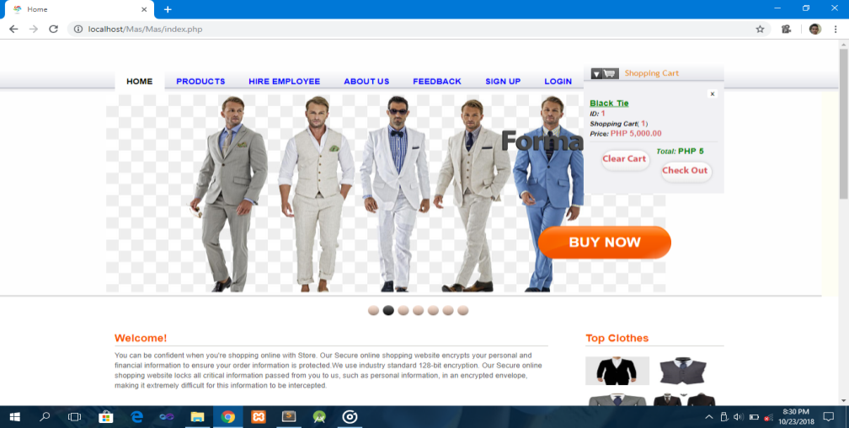

Login Form

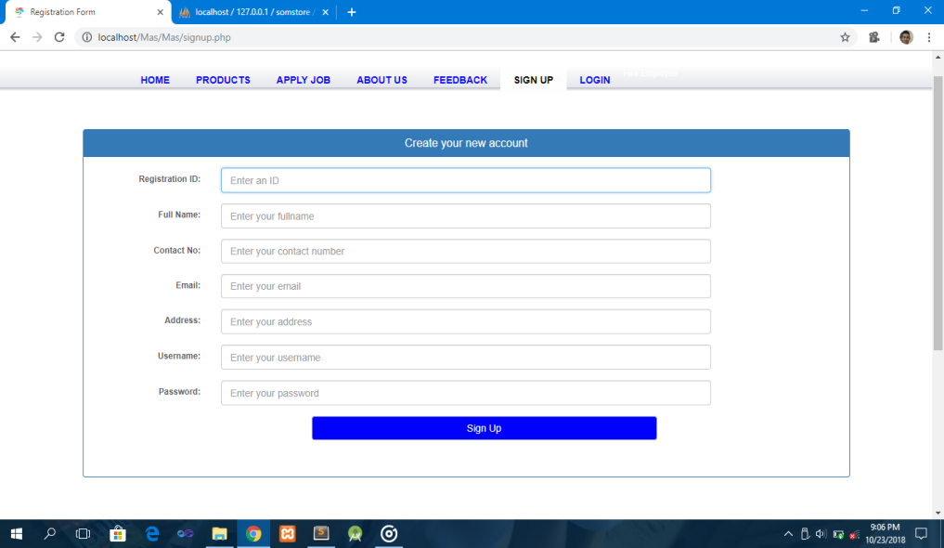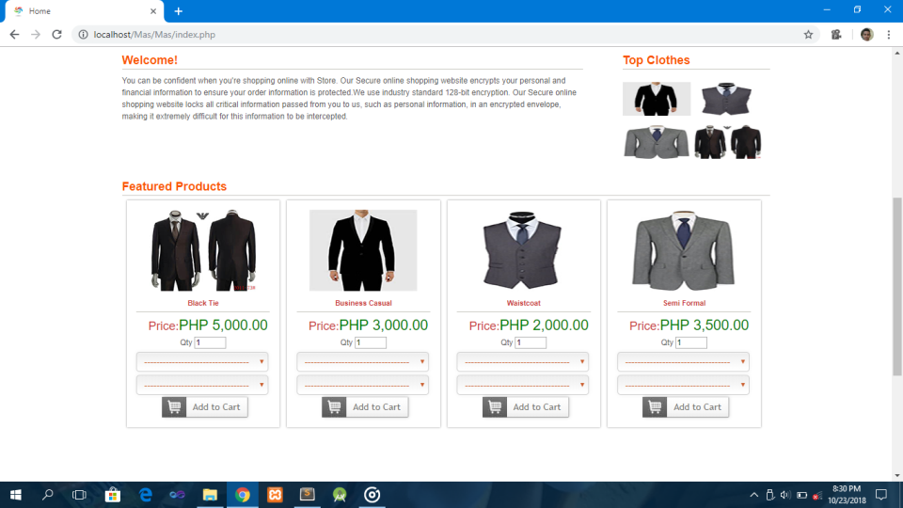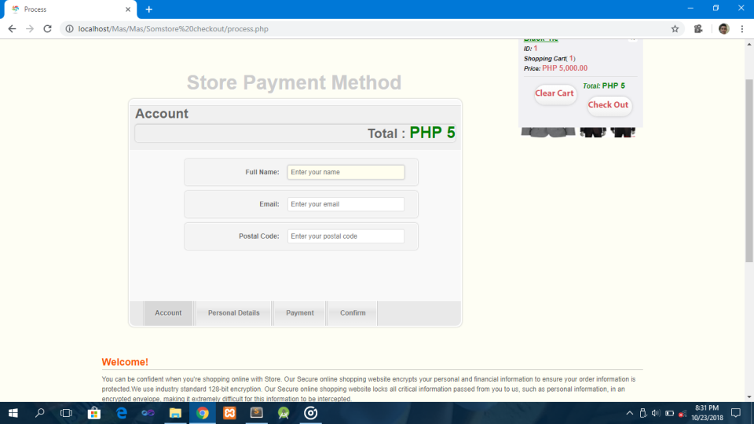

Fill Up the payment Form

Fill Up the personal Detail

Fill Up the account form

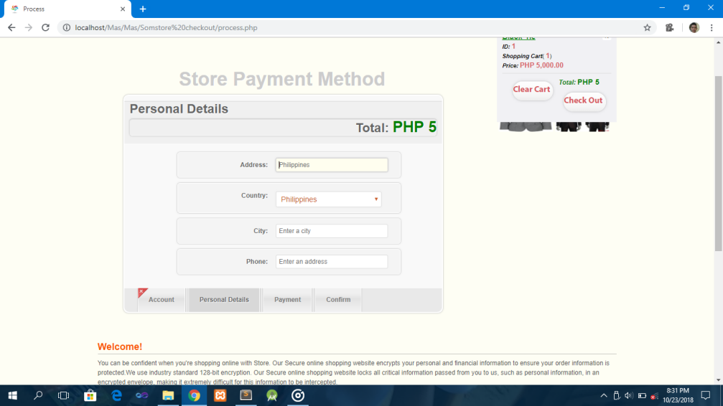

Shipping Fee

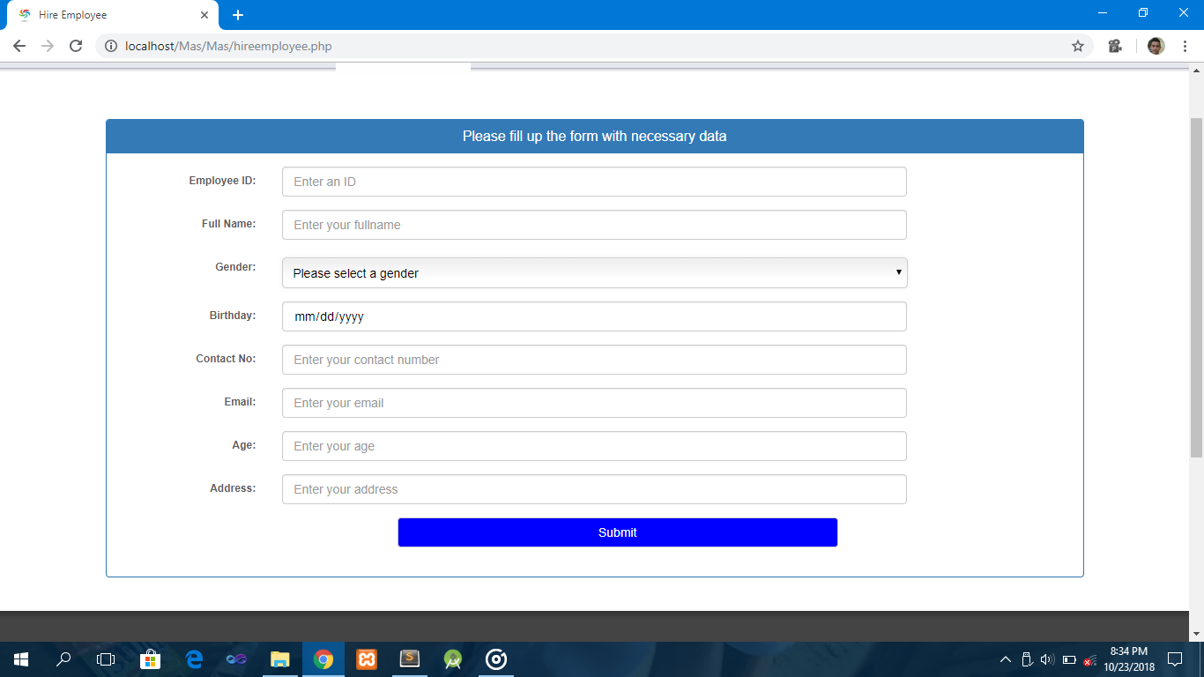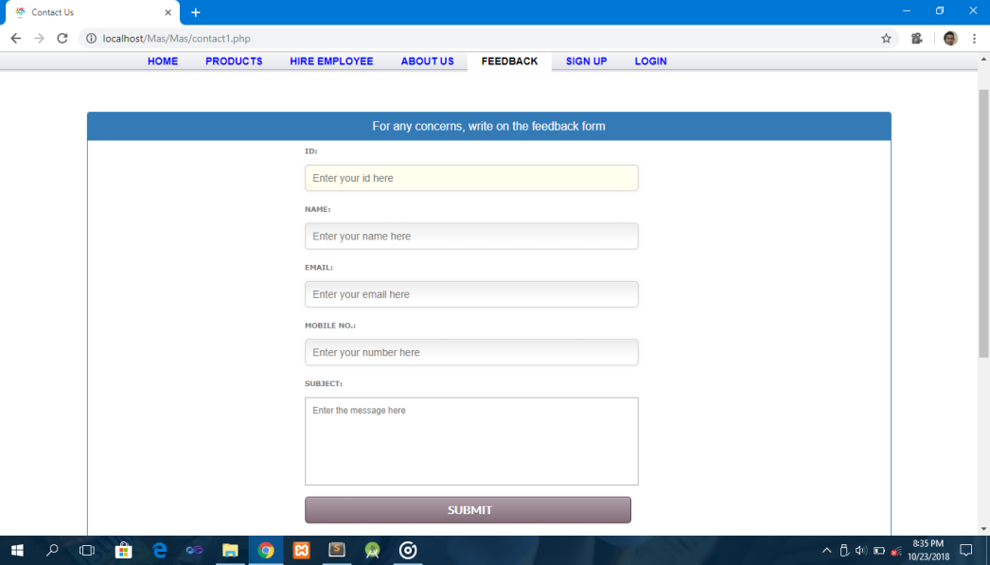

Hiring Employee’s Form

User Feedback

3.4 Performance

3.4.1 Capacity

3.4.2 Availability

The system can access anytime, anywhere from web browser.

3.4.3 Latency

**3.5 Manageability/Maintainability**

**3.5.1 Monitoring**

**3.5.2 Maintenance**

In case of failure a program will be done and the maintainability can be done efficiently.

**3.5.3 Operations**

If the customers want to by an item he/she must go to the website. First users must login/create an account after that the system shows all product categories for the customer. If customers select the item then they listed on shopping cart for buying. But if customers want to cancel the order it will allow for them. Then after all the process customer can see the buying report on account detail.

**3.6 System Interface/Integration**

**3.6.1 Network and Hardware Interface**

The system must run over the internet. So that, all the hardware shall require to connect the internet

**3.6.2 System Interface**

The system is on the server it is required Data Base to store any transaction from the system and the user must have a web browser to access the shop.

***3.7 Security***

3.7.1 Protection

This system has a protection from malicious including :

* Admin can’t view user information such password
* Password encryption
* User cant login without account

**3.7.2 Authorization and Authentication**

## 3.8 Data Management

Requirements to be placed in data base including;

* Registration, products, delivery details.
* Anytime
* Registration, records, hiring information
* data entities and relationships
* login with an existing account to access
* keeping data within data base and extra copies
* no registration if there is an existing account, registered account can access easily,
* 25 rows
* Text, VarChar.

**3.9 Standards Compliance**

**3.10 Portability**

The end user part is fully portable in any system using any web browser should be able to use the features of the system. The system shall run on Laptop, PC and Mobile Phone.